Dr. Kaleem Saifullah 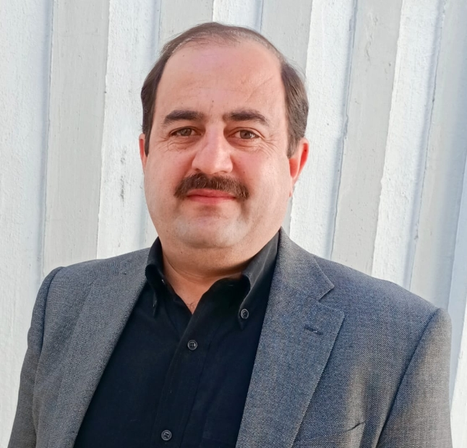

PERSONAL INFORMATION
Phone No: +923005866332
E-mail: kaleemkk@hotmail.com & kaleem@hu.edu.pk
N.I.C # 1 7101-0416474-1
Date of Birth: August 26, 1982

OBJECTIVE
Experienced and enthusiastic university educator with evident record of fostering a results-driven and engaging learning environment for students of management sciences at a higher education level. Adept in developing an interactive, innovative and industry based curricula to foster critical thinking, leadership, problem solving skills for lifetime learning. Enthusiastic to contribute my passion for teaching, industry insights, and academic expertise to an esteemed university to promoting a culture of socially responsible, excellence, guide and inspire graduates as next generation leaders.

EDUCATIONAL HISTORY
2022 PhD (Management Sciences) CGPA: 3.55/4.00
Department Of Management Sciences, Hazara University

2013 MS (Management Sciences) CGPA: 3.80/4.00
Department Of Management Sciences, Hazara University

2004 – 2005 MBA (Finance)
IBMS/CS Agricultural University Peshawar CGPA: 3.64 /4.00

2002 - 2004 BBA
IBMS/CS Agricultural University Peshawar CGPA: 3.31/4.00

1999 - 2001 FSc (Computer Science)
Iqra Academy , Abbottabad.
MAJORS IN MATHS, PHYSICS & COMPUTER Marks: 612/1100

1998 - 1999 Matriculation
Iqra Academy , Abbottabad.
MAJORS IN MATHS, PHYSICS, CHEMISTRY & BIOLOGY Marks: 594/850

EXPERIENCE

1 From December 14th, 2006 to June 14th, 2007 worked as Lecturer (BPS-17) at Department Of Management Sciences, Hazara University, Mansehra.
2 From June 15th, 2007 to November 22nd, 2007 worked as Warden Hazara University, Mansehra.
3 From November 23rd, 2007 till dated working as Lecturer(BPS-18) at Department Of Management Sciences, Hazara University, Mansehra.

ADDITIONAL ADMINISTRATIVE RESPOSIBILITIES DURING WORK EXPERIENCE

1 Warden boys hostel.
2 Coordinator BBA Program.
3 Focal person PMNLS (Till Date).
4 Exam Coordinator, Department of Management Sciences Hazara University.
5 Faculty Proctor (Till Date)

TRAININGS/CERTIFICATE COURSES ATTENDED

1 Islamic Finance Certification Program for Business Faculty organized by NIBAF, Islamabad Pakistan.
2 Islamic Banking Branch Operations (IBBO-20) organized by NIBAF, Islamabad Pakistan.
3 University Governance & Examination System organized by Hazara University Training Center (HTC) Mansehar.
4 Fundamentals of Islamic Banking Operations organized by NIBAF, Islamabad Pakistan at COMSATS Institute of Information Technology, Abbottabad.
5 Concepts: Education, Quantity, Quality, Standards & Developing Quality Culture organized by Hazara University Training Center (HTC) Mansehar.

PUBLICATIONS
1 The effect of self-esteem and organizational identification on organizational citizenship behavior: A case of Pakistani Public Sector University. African journal of Business Management, 5 (9), pp. 3448-3456.

2 The effect of personality on impulsive and compulsive buying behavior. African Journal of Business Management, 6(6), 2187-2194.

3 Effects of Job Satisfaction, Organizational Commitment and Work-Family Conflict on Employees Turnover Intensions: A Case Study of Private Banks in Islamabad, Pakistan. Journal of Social and Organizational Analysis, 2015.

4 Impact of organizational identification on work role performance among virtual workers: A case study of banks operating in Mansehra. International Journal of Business and Management Sciences, 3(1), 117-136.

5 Employees Voluntary Green Behavior: The Role of Servant Leadership and Psychological Empowerment. NUML International Journal of Business & Management, 17(1), 1-18.

6 Workplace Ostracism And Counterproductive Work Behaviours: A Moderated Mediation Analysis Of Organisational Cynicism And Emotional Intelligence In The Educational Sector. International Journal of Contemporary Issues in Social Sciences (IJCISS), Vol 2, Issue 3, 2023, pp. 251-263.

7. EMPLOYEES’ ENGAGEMENT AND CUSTOMERS’ LOYALTY FOR UTILITARIAN SERVICES: A MODERATED MEDIATION MODEL. Humanities & Social Sciences Reviews, Vol 9, No 3, 2021, pp 398-405.

