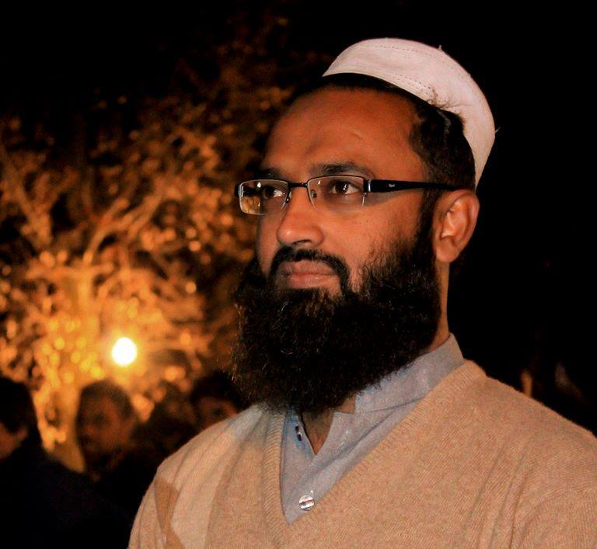


Faculty Resume
Name | Architect Iftikhar Ali
Personal | Department: Architecture  Date of Appointment:18-03-2014  Email Address: iashah54@gmail.com /arch.iftikharali@hu.edu.pk  Contact No :) +92-334 86 93 734rtinent.
Education | - M. Arch in 2018 from School of Architecture, Art & Design (SAAD) Imperial College of Business Studies- Lahore, Pakistan.  - B. Arch in 2009 from University of Engineering & Technology-Peshawar
Experience | Designation | Institute | Years
Experience | Assistant Professor | Hazara University, Mansehra | Since Nov 01, 2018 till now.
Experience | Lecturer | Hazara University, Mansehra | May 03,2016 to  Oct 30,2018 (Regular)  &  Mar 18,2014 to May 02, 2016 (Contract)
Experience | Lecturer | UET-Abbottabad | 02- Years
Experience | Principal Architect | Bawari Group of Companies Kabul- Afghanistan | 03- Years
Honors & Award | - Best Teacher of the Year 2019 Award from Hazara University, Mansehra  - Certified Studio Instructor by BAE-IAP (Board of Architecture Education-Institute of Architects Pakistan)  - Certified Juror “INSPIRELE AWARD” International network of Student Design Studios competition 2020  - Regular “Thesis Design-I & II” Juror of Department of architecture of UET-Abbottabad Campus  - Convener of IAP-PC Academics council 2019-20, A council constituted by IAP-PC officials and academic Coordinators of 4-regional schools of KP i.e. UET-Abbottabad, Hazara University, CECOS University Peshawar & City University-Peshawar.
Professional Trainings/ Workshops Arranged, Participated or as Resource person/ Instructor | - Attended ARCASIA Emergency Architects AEA/ACSR workshop series 2020 - Co-Inventing Built Environment Nov 22, 2020.  - Attended Thesis Design Juries (FYP) 2020 of Department of Architecture-UET Abbottabad campus as an External Juror.  - Attended online Training arranged by UNESCO Chair Program on Cultural Heritage and Risk Management Workshop on “Good Practices for Disaster Risk Management of Cultural Heritage” Dates: 8th to 10th October, 2020.  - Attended a Training arranged by ProQuest and HEC on “E-book Central Advance Training” on September 16, 2020.  - Participated in 5-Webinars organized by IAP, LEAP for CPD during COVID-19  - Two Days “Design Process-I” Workshop at Department of Architecture Hazara University 3 –4 November 2019, as an Internal Resource Person  - Training “Studio Teaching Methodologies” at Hazara University, 27-28 Aug 2019.  - Three Days Design Schematics Workshop, Hazara University, 16-18 April 2019 as Resource Person  - Participated in “Round table of stakeholders on implementation of Antiquities Act 2016 KP” on 19 Feb 2019 in CECOS University Peshawar.  - “Two Days Design Workshop” Department of Architecture Hazara University, 17-18 December 2018 organized by IAP-PC  - Participated in Design charrette organized by IAP-PC in IAPEX as a Design Studio Instructor in 8-10 Oct 2018.  - Participated in 10-Days Workshop organized by HUDA and NED-UET Karachi at Gilgit Baltistan titled as “INTO THE NATURE-2” From 09-18 Oct 2017.  - Schematics (Design Process Workshop) 17 April 2017  - Participated in 10-Days Workshop organized by HUDA and NED-UET Karachi at Neelam valley titled as “INTO THE NATURE” From 26 May 2016 to 5th Jun 2016.  - Participated in DDP-II workshop in UET Abbottabad campus as a studio instructor held on 23-25 May 2016.  - Digital Design Studio Workshop-II (Revit Architecture) at AIMS Architects and Engineers, Mandian Abbottabad from 6th to 8th Nov 2015.  - Design Studio Workshop-I contributed as a Juror on 13-14th October 2015.  - Participated as a Studio Instructor at IAP-EX Student Jamboree Held at CECOS University Peshawar from 23rd to 26th May 2015.  - 5-Days Workshop on Design Conducted by Ar. Nuno Soares (Portages) and Dr. Thomas Daniel (New Zealand) organized by BAE-IAP in Islamabad from 19th - 24th Oct 2014.  - Professional Practice Workshop by Ar. Azra Zaigham from May 26th to 27th 2014 held at UET Abbottabad Campus.  - Participated in workshop “Sustainable Urban Design” held on May 14th to 17th 2014.  - 3-Days Design Workshop “Think & Ink-II” By Ar. Naseer Ahmad Khan held in Deptt. of Architecture, Hazara University Mansehra from 12th to 14th May 2014.  - International Project Management Workshop (15-Days)  6-20th June 2010 at Serena Hotel, Kabul, Afghanistan.  - Design Discovery Pakistan (2ND To 14th July 2007),  In UET Abbottabad Campus (14 days Design workshop)  - Digital Architecture Workshop-1 & 2 2005, 2006 (3 days workshop) Introduction to Sketch up
Professional Memberships | - Member-Pakistan Council of Architects & Town-planner (PCATP)  - Member-Institute of Architects Pakistan (IAP)
Undergraduate Students supervised up to 2019 | - Thesis Design Studio +90 students
Honors Students | - 2-Supervised Student of Batch-IV awarded with IAP, KBA-Award & 1- Student nominated for socially responsive Design Award.
Departmental Level services at  Hazara University | - Academics Coordinator  - Member Board of Studies  - Member Scholarship Committee  - Member departmental Discipline committee  - Member Departmental development committee

Brief Statement of Research Interest | - Sustainable Architectural Design  - Interested in Urban Design  - Religious Architecture and its contemporary practice  - Working on Public open Spaces Design and its parameter

Research Publications | - Research Paper Titled, “Bridging the gap. Walled cities: Peshawar and Lahore” published in HEC Recognized in Category “Y” Open access journal, Journal of Asian Civilizations ,Vol. 43, No.1, June 2020  - Research Paper Titled, “The Significance of Islamic Architecture; The Case of First mosque in Madinah & Contemporary Practices” published in HEC Recognized in Category “Y” Open access journal, Hazara Islamicus Jul-Dec 2019 Issue.  - Research Paper Titled, “Learning from The Vanishing Built Heritage (A Case of colonial buildings in Abbottabad City-Pakistan)” Presented in International conference ICMTSMR-University of Kotli on 15-17 November 2019, and abstract published in Conference Proceedings.  - Research Paper Titled, “Key Factors Affecting Architectural Education in Pakistan” Presented in 2nd International Conference on Regional Challenges and Exploring Sustainable Solutions (RCESS-II) on 27 –29 September 2019 and abstract published in Conference Proceedings.  - Research Paper Titled, “Buildings needs to breath; a case of interventions of traditional building of Agriculture university, Faisalabad old campus” Presented in 1st International Conference on Regional Challenges and Exploring Sustainable Solutions (RCESS-I) on 8-10 Oct 2018 and abstract published in Conference Proceedings.  - Research Paper titled: “sustainable design development conflicts & Community settlement – A case of Innovative Emergency Responsive shelter for IDP’s, Sheikh Shahzad Camp Mardan, Khyber Pakhtunkhwa presented in ICETEMS-2016, Abstract published in CUSIT-Peshawar, Khyber Pakhtunkhwa, Pakistan.  - Research Paper Titled: “Public spaces as a showcase of urban cultural landscapes-Sustainable design for built environment as an instrument for the developments of the communities” Full paper accepted in PIBEC-2017 Conference, Malaysia.  - Research paper Titled: Environment responsiveness in design through site orientation” A study of buildings in Abbottabad City, Pakistan”. Abstract published in Gell Conference 2008, UK.
International / National Design Competition | - Participated in International Design Competition “Urban Adaptation” dated 2020-09-01 ~ 2020-12-31 organized by Metsawood (https://www.metsawood.com/global/Campaigns/urbanadaptation/Pages/default.aspx#THE-COMPETITION .  - Participated in National Open Design Competition for IAP-Karachi Chapter "Rehabilitation & Adaptive Re-Use Ideas and Design National Competition 2020" held in collaboration with Pakistan National Shipping Corporation (PNSC) from Oct 21 to Nov 30, 2020.  - Participated in International Open Design Competition JDC 2020 International Competition In Architectural Design: Super Residence Oct 25 to Nov 28, 2020.  - Participated in National Open Design Competition for IAP ZERO CARBON DESIGN COMPETITION organized by IAP-RWI chapter from Jun 20, to Aug 2020.  - Participated in International Open Design competition URS China Interactive Public Art Installation Design Competition 2020 LINGYUN LANE organized by Designverse Design Competition firm (https://www.designverse.com.cn/) 2020-01-21 ~ 2020-06-30  - Participated in International Open Design Competition for Jiaxing Bus Shelter International Design Competition 2020 organized by Designverse Design Competition firm (https://www.designverse.com.cn/) 2020-10-01 ~ 2020-04-21  - Participated in International Open Design Competition for Minaret Design, Bunyan Competition for Architecture in the Islamic Context | 2019, organized by Bunyan architectural foundation- Qatar 2019-11-25 ~ 2019-12-10 and qualified for the first phase of Public Voting.  - Participated in Young Bird Plan 2018 On the Frontier Toilet Design Competition 2018-09-28 ~ 2018-11-21 as a Team Leader  - Participated in the open competition for the renovation of the historical city of FEZ Morroco, with the collaboration of the Gaheez Consultants-Peshawar Aug 16, 2010 to April 30, 2011.
Research Projects/ Seminars/ Professional Events | - Research Project: ICORP-ICOMOS on the Road Project, Episode # 4 Pakistan, 21st to 31st March 2019 Swat-Swabi KP worked as a Deputy coordinator for the overall project in Pakistan representing Hazara University and IAP-PC.  - Overview  - Got the flag of honor from ICORP -Turkey for successful completion of the project.  - It’s the video documentary exploring the story of hidden heroes of protection of cultural heritage in times of Risk in the valley of Swat & Swabi- KP, Pakistan.  - The overall budget allocated was US$ 31,000/- Sponsored by TIKA-Turkey, ICOMOS-Pakistan & IAP-PC.  - Campfire Talk Swat: 23rd March 2019 (7-Schools of Architecture) participated and worked as an organizer.  - Salient Features  - Opportunities for Students networking with various leading schools of the country  - Budget allocated by IAP-PC for this event is Rs200,000/-  - International Symposium: 1st International Symposium of Cultural Heritage Protection and Raising Awareness-I  - Salient Features  - Worked out all activities and its budgeting along with successful implementation of activity plans.  - Students of All KP- Schools of Architecture and U o Swabi participated  - Budget allocated by IAP-PC for this event is Rs200,000/-

